Students share your Kaltura MediaSpace media within D2L Brightspace (KA #1749)

Published 11/02/2016 | Updated 12/9/2021

Audience: Learner

**How can I allow others see a video or audio file that I have in my MediaSpace account?  Can I share a media file with my classmates and instructor in my online class?**

Table of Contents

Overview 1

Add media in D2L Brightspace 1

Add media in HTML Editor using Insert Stuff > My Media 3

Select an existing media file from your MediaSpace account 5

Add a new media file to your MediaSpace account 5

Record an audio and webcam video from your web browser 7

# Overview

Within Kaltura MediaSpace, you can upload media, share media files, and use/download the Kaltura Capture tool. Your instructor may ask you to use MediaSpace for presentations, interviews, and other assignments.

When using MediaSpace, first upload your media file into your MediaSpace account, and then check to ensure the media visibility is set to Unlisted (visible to users with the direct link). Check out [how to upload your media file to Kaltura MediaSpace](https://mnscu.sharepoint.com/sites/D2Lsupport/learner/1769.docx?web=1) (article #1769) to learn more.

Once you’re ready to share you media with your teacher and/or classmates, you have the option to (1) embed the media file or (2) paste the media file’s URL link within the HTML Editor in D2L Brightspace.

Back to top

# Add media in D2L Brightspace

With the HTML Editor > Insert Stuff > My Media option, all media files in your MediaSpace account will be listed, regardless of the file's sharing permission (i.e. published, unlisted, private).  Because the media file will be embedded within the HTML Editor, it does not matter what the file’s sharing permission is within your MediaSpace account. After you have embedded the media file within the HTML Editor, anyone enrolled in your course can view the media file, as long as they have access to the item you are creating, updating, or posting within D2L Brightspace.

You can add a media file from your Kaltura MediaSpace account anywhere you have access to the HTML Editor within D2L Brightspace (e.g. a discussion post, an assignment folder’s comments or text submission field, a written response question in a quiz, etc.).  Depending on the course assignment, you may be asked to navigate to the Discussions, Assignments, or the Quizzes tools.

* **Discussions**: When viewing a discussion topic, you have access the HTML Editor when starting a new thread or replying to another classmate's or an instructor's post.  Add the media file using the **Insert Stuff** icon and select **My Media**. Remember to click **Post** so your **instructor can view your response.**   
  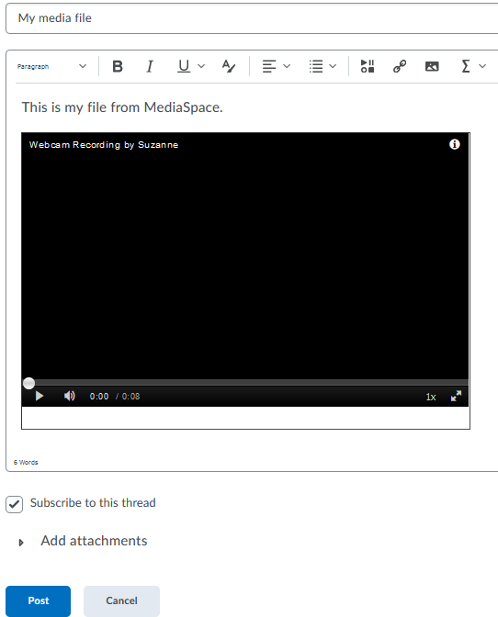
* **Assignments**: When submitting to an assignment folder, you have access to the HTML Editor when on the **Submit Files** page. Add the media file using the **Insert** **Stuff** icon and select **My** **Media**. Remember to click **Submit** so your **instructor can view your submission.**   
  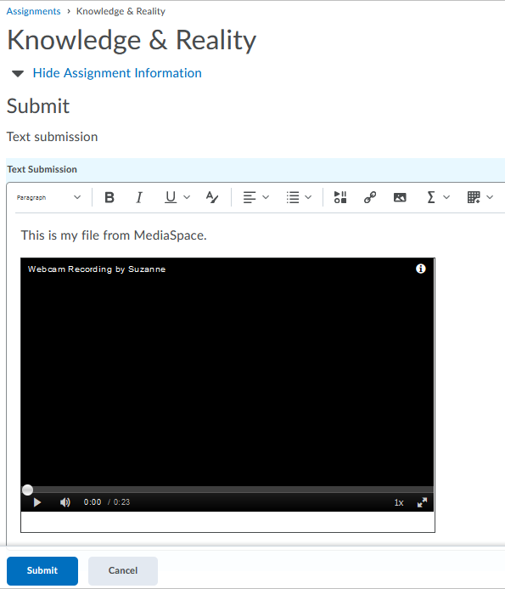
* **Quizzes**: When taking a quiz, you may have access to the HTML Editor when responding to a **Written Response** question. Add the media file using the **Insert Stuff** icon and select **My** **Media**. Remember to submit your quiz attempt **so your instructor can view your responses.**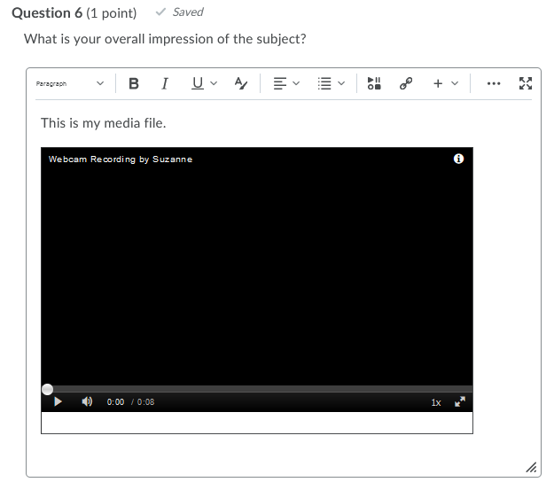

Back to top

## Add media in HTML Editor using Insert Stuff > My Media

1. Navigate to your D2L Brightspace course.
2. Create or edit the item you want to add the media file to.
3. In the HTML Editor, *click* the **Insert Stuff** icon.  
   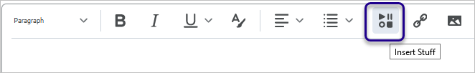
4. In the Insert Stuff window, *click***My Media**.  
   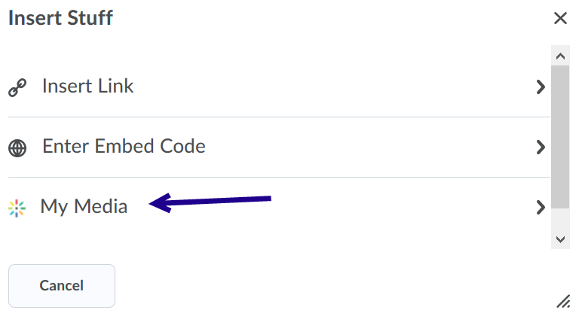
5. Your media files from your MediaSpace account will display.
6. Follow one of the processes below to:
   1. Select an existing media file from MediaSpace
   2. Add a new media file to MediaSpace
   3. Record an audio and webcam video from your web browser
7. The media file is embedded within the HTML Editor.   
   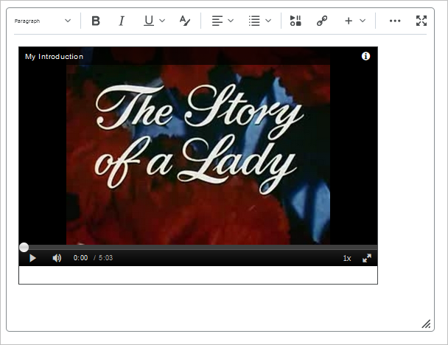
8. To save your changes within D2L Brightspace, remember to post your discussion, submit your assignment, or submit your quiz attempt.

Back to top

## Select an existing media file from your MediaSpace account

From the Insert Stuff > My Media screen, you have four options to add a MediaSpace media file. One option is to select an existing media file available within your MediaSpace Account, and then embed it into the HTML Editor.

Note: To select a file from your MediaSpace account, you must first [upload a media file to Kaltura MediaSpace](https://mnscu.sharepoint.com/sites/D2Lsupport/learner/1769.docx?web=1) (view knowledge article #1769 for instructions).

1. From the **Insert Stuff > My Media** screen, find the media file you want to embed. You have the option to search, filter, and sort media on this screen.
2. *Click* **Select** next to an existing media file from your MediaSpace account. You have the option to select a size (small, medium, large) from the **Select** drop-down menu.  
   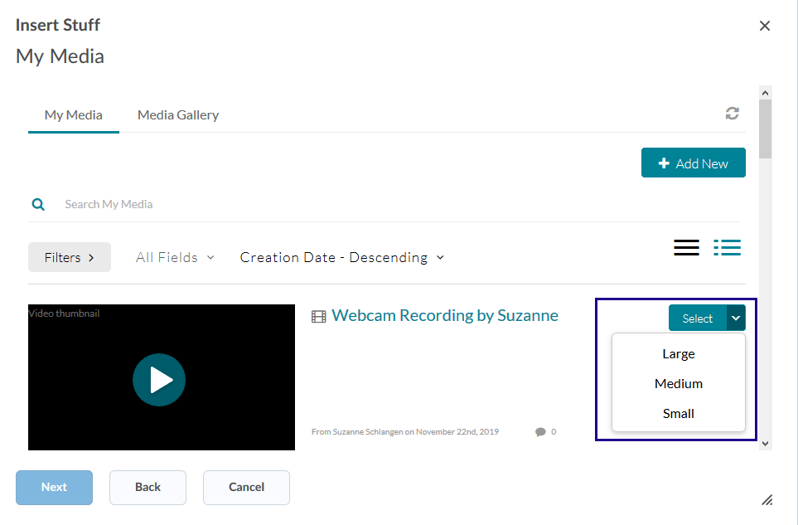
3. You can preview your media file before embedding it.  When ready, *click* **Insert**.
4. The media file is now embedded within the HTML Editor.
5. To save your changes within D2L Brightspace, remember to post your discussion, submit your assignment, or submit your quiz attempt.

Back to top

## Add a new media file to your MediaSpace account

From the Insert Stuff > My Media screen, you have four options to add a MediaSpace media file. One option is to upload an existing file from your device, upload the file to your MediaSpace Account, and then embed the file into the HTML Editor.

1. Click **Add New > Media Upload** to create an audio and/or webcam recording.   
   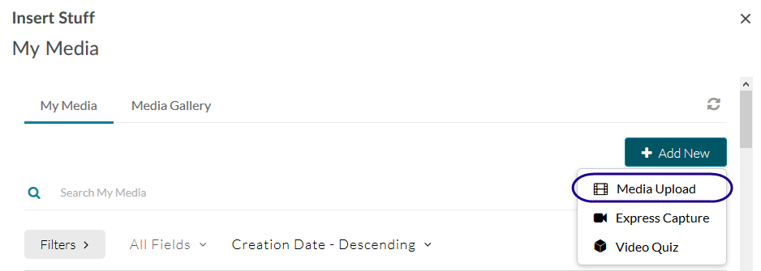
2. *Drag-and-drop* a file into the ‘upload media’ dotted line, or *click* **Choose a file to upload** to select a file from your device. You can upload video or image files.
3. Wait for your file to upload to your MediaSpace account.
4. You have the option to change the file’s **Name**, add a **Description**, and/or add **Tags**, as needed.
5. *Click* **Save and Embed** (top right of the window) to select the media file.   
   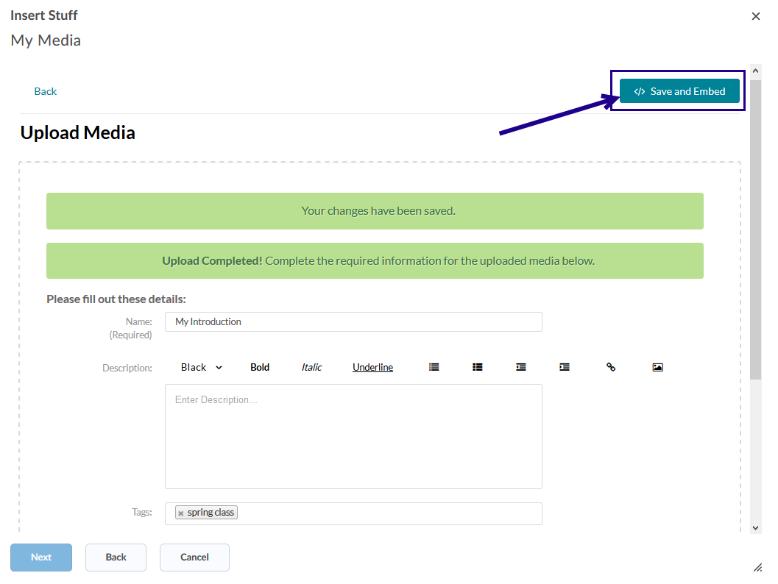
6. You can preview your media file before embedding it.  When ready, *click* **Insert**.
7. The media file is now embedded within the HTML Editor.
8. To save your changes within D2L Brightspace, remember to post your discussion, submit your assignment, or submit your quiz attempt.
   1. After embedding the media file into a discussion post, you must enter a subject in the **Subject** field and click **Post** in order to submit the post.
   2. After embedding the media file into the **Comments** field in an Assignment submission folder, you must upload a file, then click Submit in order to complete submitting the assignment.
   3. After embedding the media file into a **Written Response** quiz question, you must submit the quiz attempt (i.e. *click* the **Submit Quiz button) to submit your response.**

Back to top

## Record an audio and webcam video from your web browser

From the Insert Stuff > My Media screen, you have four options to add a MediaSpace media file. One option is to record an audio and/or webcam video using your Internet browser, upload the file to your MediaSpace Account, and then embed the file into the HTML Editor.

1. Click **Add New > Express Capture** to create an audio and/or video recording.   
   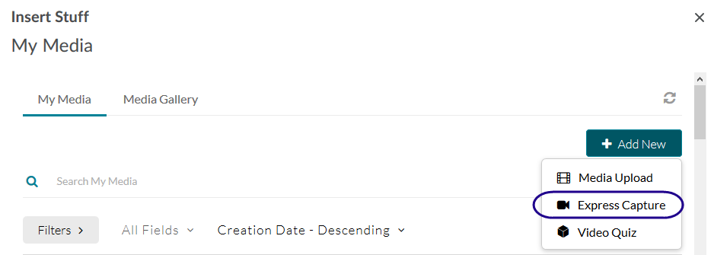
2. If prompted, click **Allow** to utilize your microphone and/or webcam in the Internet browser.  
   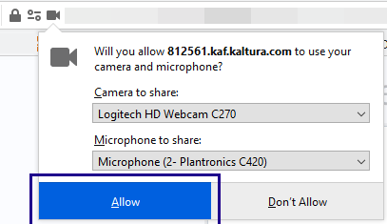
3. *Click* the record circle button to start the recording.  
   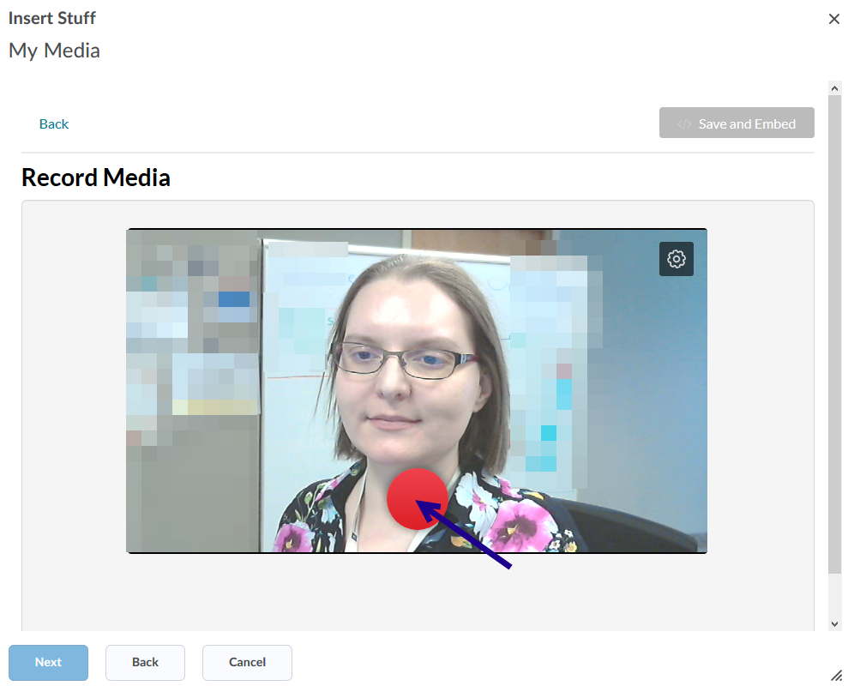
4. Record your video, and then press the stop button to finish recording.  
   Note: There is no pause button. This feature is intended to support a single, continuous recording.   
   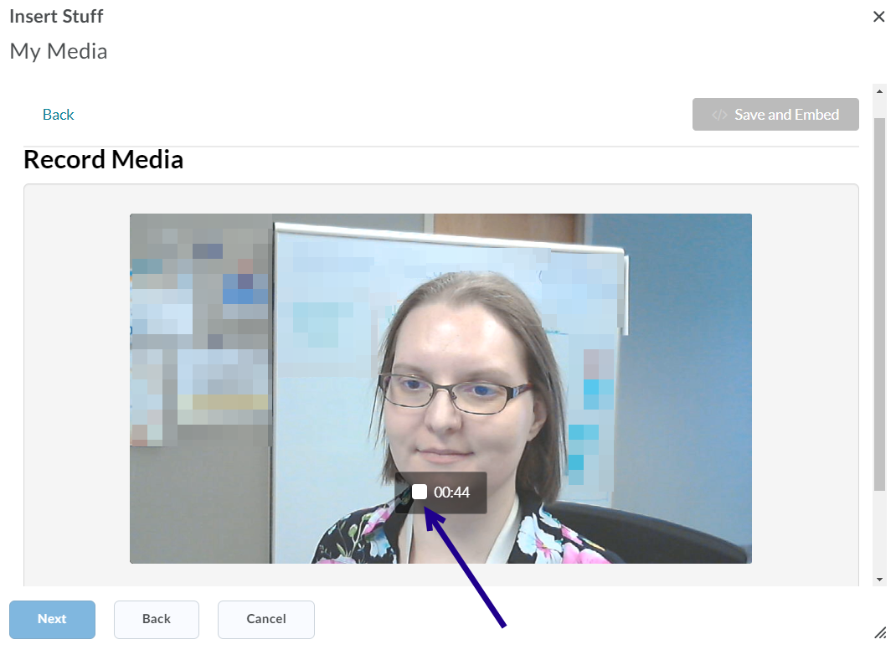
5. When ready to use your video, click **Use This**.  
   Note: You also have the option to preview your recording, and/or record again.  
   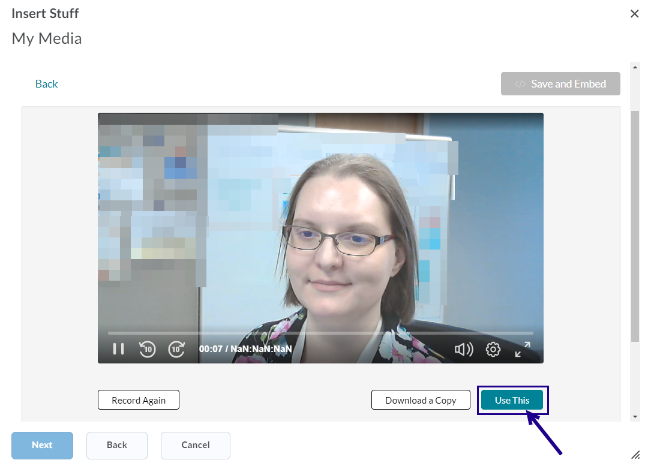
6. Wait for video to upload to your MediaSpace account as a new upload.
7. By default, the video **Name** is “Video Recording - <Day of week Month Day Year HH:MM:SS GMT-0600 (Central Standard Time)>”. You may rename your video using the **Name** field and click **Save** (bottom left within the dialog window) to save your changes within your MediaSpace account.
   * Note: The video setting is Private. Since you are embedding the video with the HTML Editor, it will be visible to users who have access to the item within your D2L Brightspace course.
   * For example, if you embed your media file within a student’s Assignment feedback and publish the feedback, that specific student will be able to view the video within the D2L Brightspace course. As another example, if you embed your media file within an Announcement item and publish the item, all students who view the announcement item can view the embedded media file.
8. Click **Save and Embed** (top right of the window) to select the media file.   
   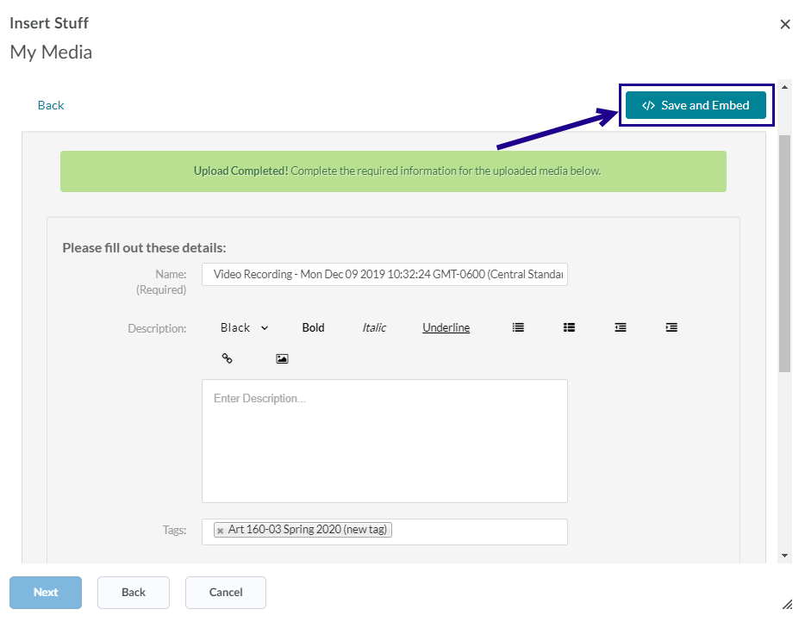
9. You can preview your media file before embedding it.  When ready, *click* **Insert**.
10. The media file is now embedded within the HTML Editor.
11. To save your changes within D2L Brightspace, remember to post your discussion, submit your assignment, or submit your quiz attempt.

Back to top